**NEURAL NETWORK**

**Business Problem** = ﻿﻿Build a Neural Network Model for 50_startups data to predict profit.

* **Name of the File: -** 50_Startups.csv
* **Size of the File: -** 2 KB
* **Data: -** 50 Observation, 5 Variable
* **Column Name: -** R&D Spend, Administration, Marketing Spend, State, Profit

**Exploratory data Analysis** =

* **Outliers: -**  Profit variable having outliers.
* **Missing Value: -** Data don’t have Missing Values
* **Normality: -** Data are near normal

**Scatter plot =**

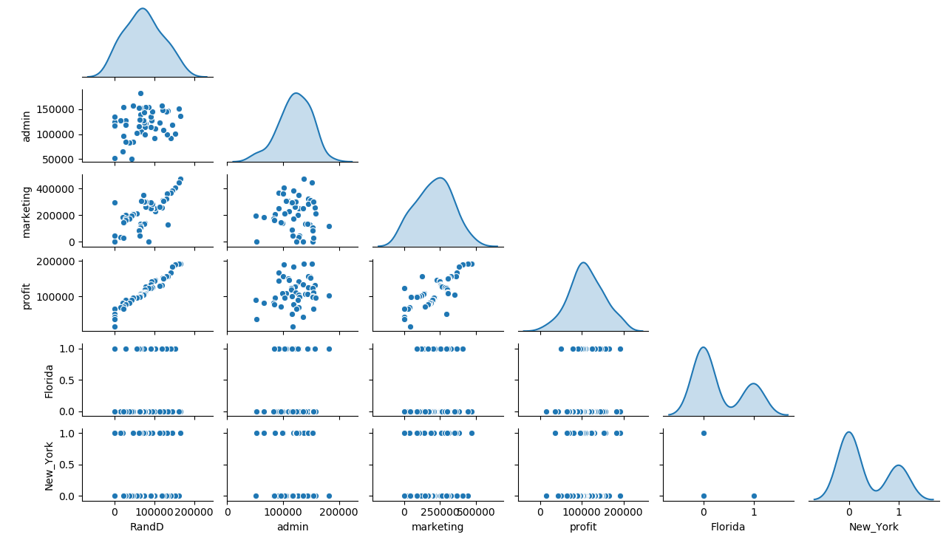

**Correlation Coefficient (r) =**  Correlation between marketing and R&D is quite high as compare to other it may causes collinearity problem.

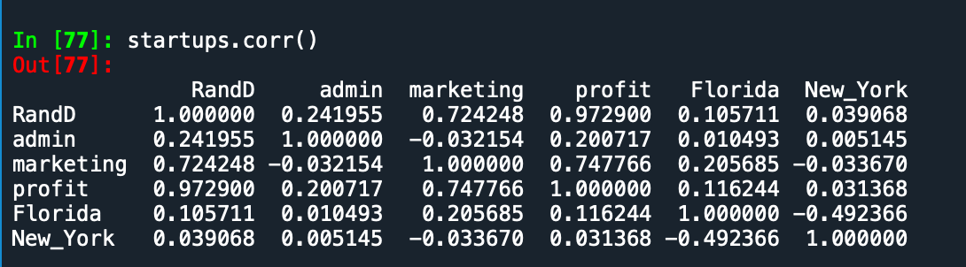

**Model ANN Building =** Building model by considering following parameters.

* **﻿Activation :-** Relu
* **﻿Neurons :-** 100
* **Epochs-** 200

**Accuracy of Model =**

* **Accuracy Train : -** 96%
* **Accuracy Test : -** 98%
* **RMSE Train : -** ﻿61847
* **RMSE Test :-** ﻿74017

**Python code file**: - [50_Startups Analysis.py](https://github.com/nilaydeshmukh0/Artificial-Neural-Network/blob/master/50_Startups%20Analysis/50_Startups%20Analysis.py)